UNIVERSITY OF THESSALY
SCHOOL OF ENGINEERING
DEPARTMENT OF MECHANICAL ENGINEERING

LABORATOTY OF MECHANICS  AND STRENGTH OF MATERIALS  Pedion Areos  38334 Volos  GREECE | Director: Professor Nikolaos Aravas  Tel..: +30-2421-074 002  FAX: +30-2421-074 009  e-mail: aravas@uth.gr
FINITE ELEMENT IMPLEMENTATION OF A RATE-DEPENDENT ELASTOPLASTIC DAMAGE MODEL THAT ACCOUNTS FOR HYDROGEN EMBRITTLEMENT OF PIPELINE STEELS
by
Dr. Ioanna Papadioti, Dr. Sokratis Xenos and Prof. Nick Aravas

- Introduction
In the present report we describe the general form of the constitutive equations of a damage model that accounts for hydrogen embrittlement of pipeline steels. Numerical implementation of the model is based on a thermomechanical analogy and the similarities between the heat transfer and diffusion problems. Our methodology is implemented in the ABAQUS general purpose finite element code via a “user material subroutine” UMAT in ABAQUS/Standard and VUMAT in ABAQUS/Explicit.

Section 2 briefly discusses the elastoplastic damage model and Section 3 introduces the hydrogen diffusion problem. Finally, Section 4 provides a detailed description and implementation guidelines for the UMAT and VUMAT subroutines.

- Description of the constitutive model
The model presented in the following is a version of the damage model of Bai and Wierzbicki (2008, 2010) as modified by the Aachen group (Lian et al., 2012; Wu et al. 2017).

A rate-dependent von Mises type plasticity model is used, in which the yield function is written in the form
where 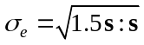 is the von Mises equivalent stress, 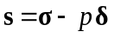 is the stress deviator, 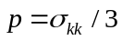 is the hydrostatic stress, is the second-order identity tensor with Cartesian components the Kronecker delta 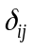, 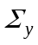 is the flow stress of the material, 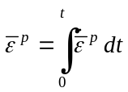, 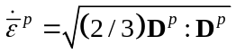, is time, 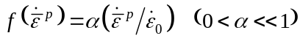, 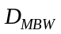 is a damage parameter defined in detail in the following, and  is the total hydrogen concentration which is defined in Section 3.

The flow stress is assumed to be of the form
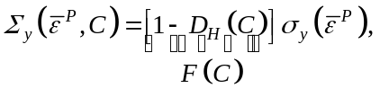
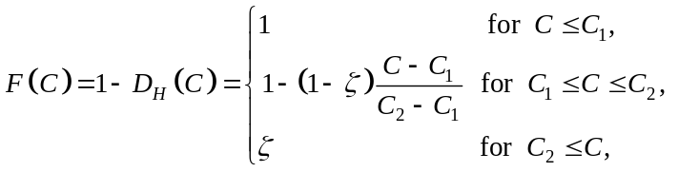 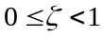,
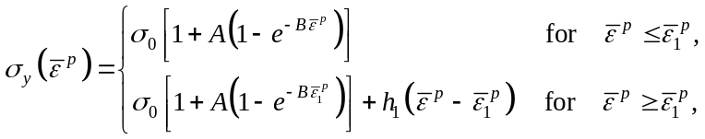

Note: The yield condition can be written in the form
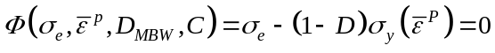,
where the “total damage” 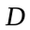 takes the value of 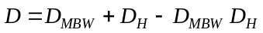.

The ductile damage parameter is calculated as described in the following. Ductile damage is assumed to initiate when the “ductile damage indicator” 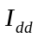 reaches the value of 1, where
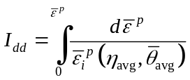, 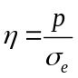 (triaxiality), 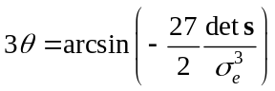 (Lode angle) 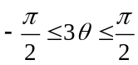,
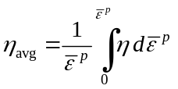, 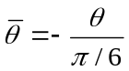, 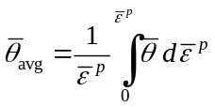,
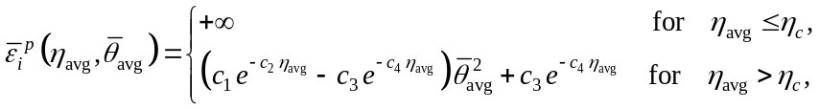
with 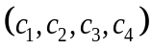 being dimensionless positive material constants. Let 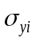 and 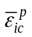 denote the corresponding values of the material flow stress 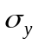 and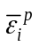 when 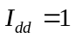. Once the condition is satisfied, the dimensionless damage parameter starts to evolve according to the relation
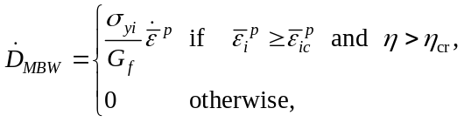
where 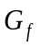 is a material parameter with dimensions of energy per unit volume and 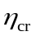 is a critical value of stress triaxiality below which local material failure never occurs (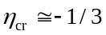; Bao and Wierzbicki, 2005).

- Failure criteria
A criterion for brittle fracture based on the maximum principal stress is simultaneously implemented along with a criterion for ductile fracture, as described in the following.
Let 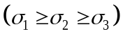 be the principal stresses at a material point. Quasi-cleavage failure 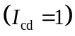 is assumed to occur when the condition 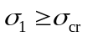 is satisfied, where 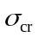 is a material parameter. The critical cleavage stress 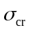 is assumed to be a function of the total hydrogen concentration, i.e.,
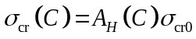, 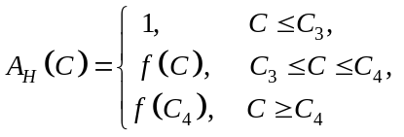
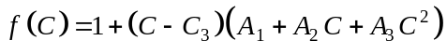,
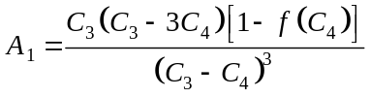,
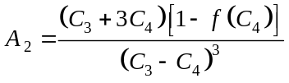,
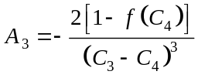,
where 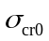 is the critical cleavage stress for the hydrogen-free material. Function 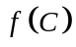 is designed so that 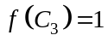, 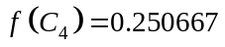, and 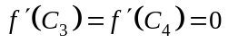.

The criterion for ductile fracture is based on a critical value of a “failure indicator” 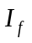 whose evolution is given as
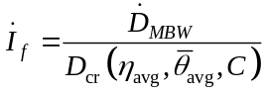,
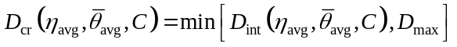,
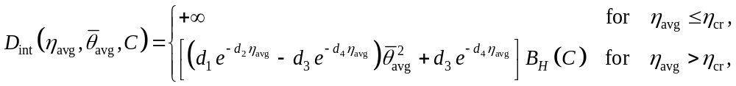
where 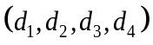 are dimensionless positive material constants and 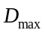 is an upper limit to the value of to make sure that 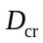 is always 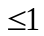. The factor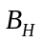 is introduced in to account for the effect of the total hydrogen concentration on ductile failure and is proposed to be of the form
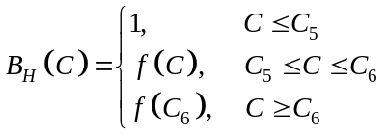
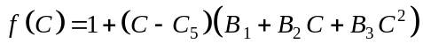,
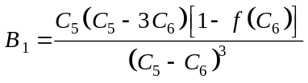,
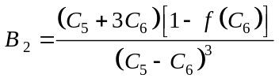,
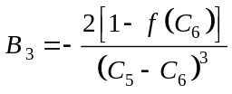.
Local ductile material failure is assumed to occur when the failure indicator reaches the value of unity, i.e., when 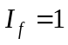. Function is designed so that 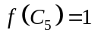, 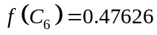, and 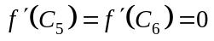.

A schematic representation of the damage model is shown in Fig. 1.
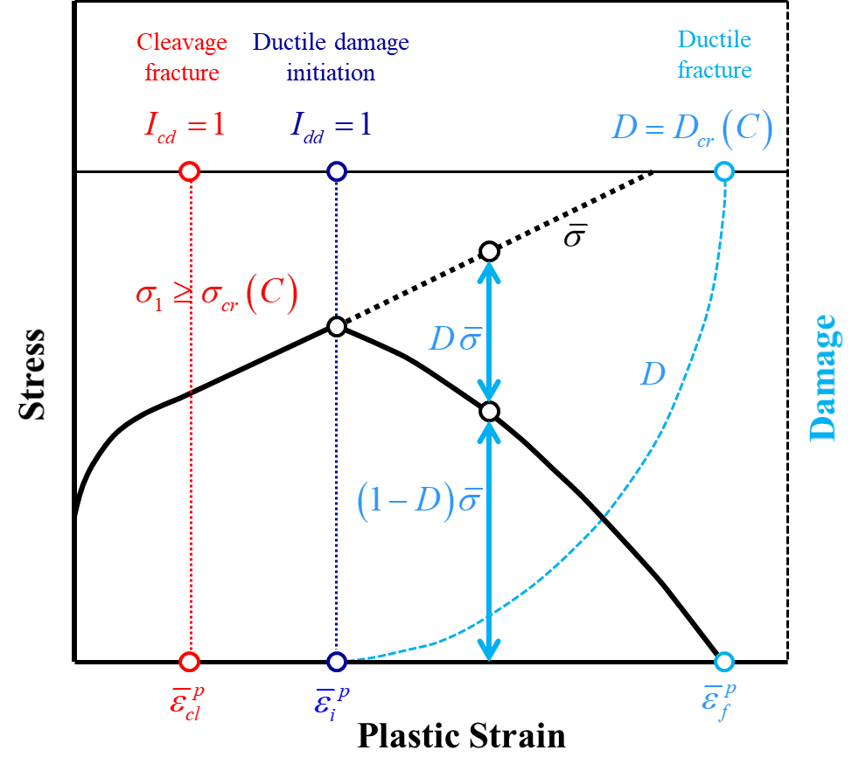
Figure 1. Schematic representation of the damage model.

- Hydrogen diffusion
We consider an arbitrary part 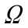 of the body under consideration. Let 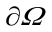 be the boundary of and unit outward normal vector to . The mass conservation equation has the form (Sofronis and McMeeking, 1989)
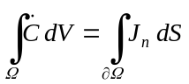 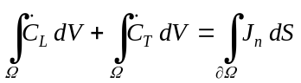,
where a superposed dot denotes the material time derivative,
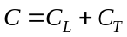 is the total number of hydrogen atoms in (H atoms/m³),
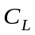 is the number hydrogen atoms per unit lattice volume (H atoms/m³),
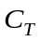 is the number trapped hydrogen atoms per unit lattice volume (H atoms/m³),
is the hydrogen flux in H atoms/(m² sec), and
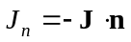 is the number of hydrogen atoms entering through per unit time per unit area (H atoms/(m² sec)).

Taking into account that and using the divergence theorem in , we conclude
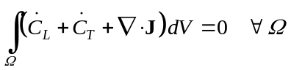 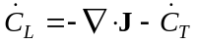,
where 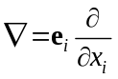 is the gradient operator, with being the unit base vectors of a fixed Cartesian coordinate system .

The boundary conditions corresponding to are
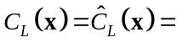known on 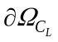,
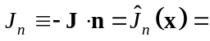known on 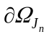,
where 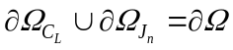 and 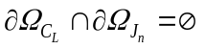.

The concentrations 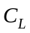 and 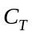 are written in the form
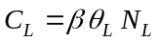 and 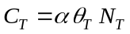,
where is the number of NILS per solvent (Fe) atom, 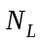 is the number of Fe atoms per unit lattice volume, 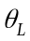 is the ratio of occupied sites to the total available sites in the lattice (in H atoms/NILS), is the number of hydrogen atom sites per trap, 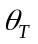 is the ratio of occupied trap sites to available, and 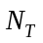 is the number of traps per unit lattice volume. Summarizing, we state the dimensions of the quantities involved in :
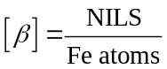, 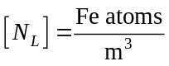, 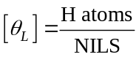,
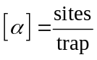, 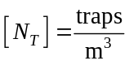, 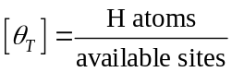.
Sofronis and McMeeking (1989) assumed that the trap density is a function of the equivalent plastic strain 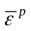, and for the BCC iron system they suggest an expression of the form
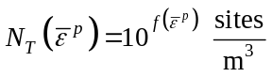 with 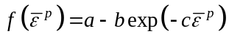,
with 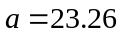, 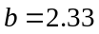, and 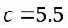.

- Instructions for running an analysis
- The analysis is based on the “thermomechanical analogy”, in which temperature (TEMP) is treated as 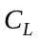.

- In cases where ABAQUS/Explicit requires a lot of time to run, we start the analysis with ABAQUS/Standard and switch to ABAQUS/Explicit when we reach the point where element elimination is required. This is done by using the *IMPORT option provided by ABAQUS (see ABAQUS documentation for more details).

- In ABAQUS/Standard the user should check the .msg file for messages like
“…THERE IS ZERO HEAT FLUX EVERYWHERE IN THE MODEL …”.
This is dangerous as it implies that ABAQUS does not verify the residuals for the diffusion problem. Should this situation arise, the user may scale the mass balance equations with respect to time (see equations - below).

- Instructions for input file
The input needed to define the material is as follows.

Mechanical Properties
- The Young’s modulus  (AE), the Poisson’s ratio (POISSON), the initial yield stress 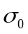 (SIG0), and the reference strain rate 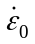 (EBARDOT0).
- The cleavage fracture parameters, 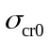 (SC), 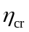 (ETAC), (C1, C2, C3, C4).
- The ductile damage parameters 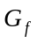 (GF), (D1, D2, D3, D4).
- The material’s initial mass density 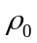 (RHO0).
- The value of the reference hydrostatic pressure 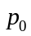 at 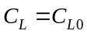 (P0).
- The parameters EXPO, SFD, EPCL, and AE0 are no longer used in the code.

Diffusion Properties
- The diffusion constant 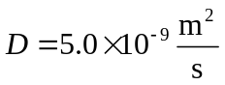(D).
- The partial molar volume of hydrogen 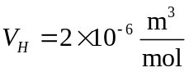(VH).
- The dimensionless constant 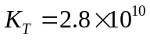 (KT).
- The number of Fe atoms per unit lattice volume 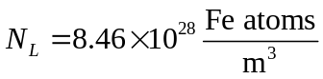(NL).
- The constant 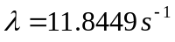(ALFREQ).
- The number of hydrogen atom sites per trap 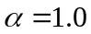(ALPHA).
- The number of NILS per solvent (Fe) atom 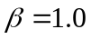(BETA).
- The value of the reference chemical potential 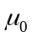 at (AMU0).
- The parameter LAMBDA is no longer used in the code.

Dimensions & material properties used in the input file are normalized as follows:
Dimensions & Time: 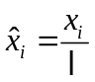, 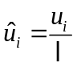, 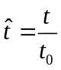
Mechanical Properties: 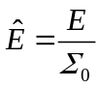, 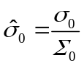, 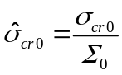, 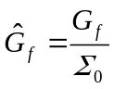,
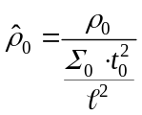, 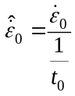.
Diffusion Properties: 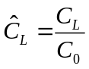, 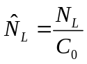, 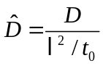, 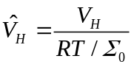,
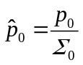, 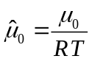, 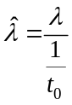.
Loads: 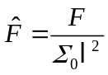.
Note: Function 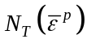 is normalized in subroutine KNT.

Normalizing Parameters
- 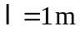(L)
- 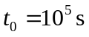 (to prevent the "ZERO HEAT FLUX" message from appearing) (T0)
- 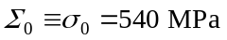 (S0)
- 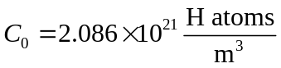 (C0)
- 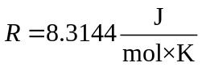 (R)
- 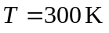 (T)

- The user should also define the initial value of the lattice hydrogen concentration. Since we are using the analogy 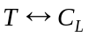, the following card is used:

*INITIAL CONDITIONS, TYPE=TEMPERATURE
Nodeset, value of 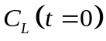

- All elements of the model must be defined in a separate filed called “Elements” using the card *ELEMENT, TYPE=…
This file is utilized by the code to read the element connectivities, which are essential for the calculation of 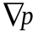.

Table 1 lists the solution-dependent variables (SDVs) that need to be stored at each increment for the specific material model.

Table 1. Solution-dependent variables for the material model
SDV # | Variable Name | Definition
1 | EBARP | Equivalent plastic strain 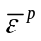
2 | YFLAG | Plasticity flag (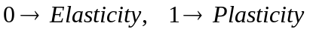)
3 | CL | Lattice hydrogen concentration 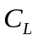
4 | CT | Trap hydrogen concentration 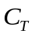
5 | GRADPX | Pressure gradient along the x-direction 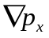
6 | GRADPY | Pressure gradient along the y-direction 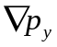
7 | CTOTAL | Total hydrogen concentration 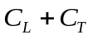
8 | CL0 | Initial hydrogen concentration in the lattice 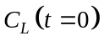
9 | DD | Ductile damage variable 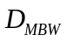
10 | AIDD | Ductile damage indicator 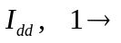 ductile damage has initiated
11 | DFLAG | Flag for ductile damage initiation, 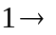 ductile damage has initiated
12 | AIF | Failure indicator 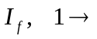 ductile failure has occurred
13 | FFLAG | Flag for element deletion, 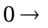 element to be deleted
14 | SYI | The value of 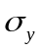 at ductile damage initiation 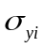
15 | ETA | Current stress triaxiality
16 | THETADEG | Current Lode angle (in degrees)
19 | DCR | Critical value for ductile damage parameter 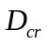
21 | U | Internal energy 
23 | RHO | Material’s current density 
24 | THETAL | Ratio of occupied lattice sites to the total available sites
25 | THETAT | Ratio of occupied trap sites to the total available
26 | DDH | Hydrogen damage variable 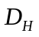
27 | AMU | Chemical potential 
29 | DCOMB | Total damage variable  due to combined damage mechanisms
30 | SCFCN | Critical cleavage stress 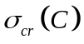
31 | DIFFS | 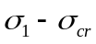
32 | FLAGCL | Flag for cleavage fracture cleavage failure has occurred
33 | FLAGD | Flag for ductile fracture ductile failure has occurred
35 | EBARDOT | Rate of equivalent plastic strain 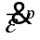
36 | SPRMAX | Maximum value of maximum principal stress 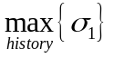 at specific material point
37 | DSTAR | Modified (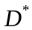) to quickly decrease the flow stress before deleting elements. is used only in ABAQUS/Explicit.
- Instructions for UMAT and VUMAT Subroutines
- In the code, the module ktransfer is used to define globally available parameters and arrays.
The parameters that should be defined by the user in the subroutines are the following:

UMAT SUBROUTINE
- Kxdim = Problem's dimension (2 in 2D, 3 in 3D problems)
- Kxmtrx = Auxialiary integer to define dimensions of DELTA etc. (4 in 2D, 6 in 3D problems)
- Kxnodel = Nodes per element (4 in 4-node, 8 in 8-node elements)
- kxelpernode = Max number of elements belonging to a node (allocate a large enough number)
- kxelem = Largest element label in the model (may skip between numbers)
- kxnode = Largest node label in the model (may skip between numbers)
- ktotalnodes = Total number of nodes in the model
- ktotalel = Total number of elements in the model
- ngaus = Number of Gauss integration points
i.e.,
parameter( kxdim = 2,
+ kxmtrx = 4,
+ kxnodel = 4,
+ kxelpernode = 10,
+ kxelem = 18000,
+ kxnode = 20000,
+ ktotalnodes = 18361,
+ ktotalel = 18000,
+ ngaus = 1)

VUMAT SUBROUTINE
- kxdim = Problem's dimension (2 in 2D, 3 in 3D problems)
- kxntens = Total components of tensors (4 in 2D, 6 in 3D problems)
- kxnodel = Nodes per element (4 in 4-node, 8 in 8-node elements)
- kxelpernode = Max number of elements belonging to a node (allocate a large enough number)
- kxelem = Largest element label in the model (may skip numbers)
- kxnode = Largest node label in the model (may skip numbers)
i.e.,
parameter( kxdim = 2,
+ kxnodel = 4,
+ kxntens = 4,
+ kxelpernode = 10,
+ kxelem = 18000,
+ kxnode = 20000)

- The flow stress parameters (, , 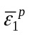, in ) are defined in subroutine KYCURVE.

- The hydrogen parameters (, 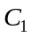, 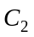, in ) are defined in subroutine KHYDRODMG.
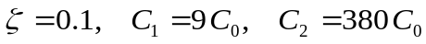

- The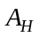 parameters (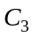, 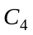 in ) are defined in subroutine KHYDRODMG.
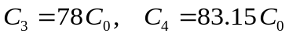

- The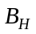 parameters (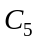, 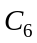 in ) are defined in subroutine KHYDRODMG.
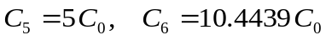
- Instructions for parallel execution via ABAQUS command line
To ensure thread safety during parallel execution, mutexes are employed in the code where global arrays are accessed for reading or writing. This approach is only effective when thread-based parallelization is specified (note that MPI is the default parallelization mode used by ABAQUS). Therefore, when running an analysis via the command line with more than 1 cpus, users must include the option mp_mode=threads to enable this functionality, i.e.,

ABAQUS/ Implicit
abaqus job=name user=UMAT_2D_3D_Hydrogen_Damage_Quad_Hex.for cpus=number mp_mode=threads

ABAQUS/ Explicit
abaqus job=name user=VUMAT_2D_3D_Hydrogen_Damage_Quad_Hex.for double=both cpus=number mp_mode=threads

- References
ABAQUS, Documentation, Dassault Systems, 2021.
Bai, Y.L., Wierzbicki, T., A new model of metal plasticity and fracture with pressure and Lode dependence. Int. J. Plast. 24, 1071–1096, 2008.
Bai, Y.L., Wierzbicki, T., Application of extended Mohr-Coulomb criterion to ductile fracture. Int. J. Fract. 161, 1–20, 2010.
Bao, Y., Wierzbicki, T., A comparative study on various ductile crack formation criteria. J. Eng. Mater. Technol. 126, 314–324, 2004.
Bao, Y., Wierzbicki, T., On the cut-off value of negative triaxiality for fracture. Eng. Fract. Mech. 72, 1049–1069, 2005.
Lian, J., Sharaf, M., Archie, F., and Münstermann, S., “A hybrid approach for modeling of plasticity and failure behavior of advanced high strength steel sheets”, International Journal of Damage Mechanics 22, 188—218, 2012.
Liang, Y., Sofronis, P., and Aravas, N., “On the effect of hydrogen on plastic instabilities in metals”, Acta Materialia 51, 2717—2730, 2003.
Liu, W., Wu, J., Fangnon, E., Maliteckii, E., Vilaça, P., and Lian, J., “Stress state effect on hydrogen embrittlement of high-strength steels”, Technology for Future and Ageing Pipelines, 29-31 March 2022, Gent, Belgium.
Papadioti, I., Aravas, N., Lian, J., and Münstermann, S., “A strain-gradient isotropic elastoplastic damage model with J₃ dependence”, International Journal of Solids and Structures 174-175, 98—127, 2019.
Sofronis, P., “Mechanics of hydrogen embrittlement”, Ph.D. Thesis, University of Illinois at Urbana-Champaign, Urbana, IL, 1987.
Sofronis, P., Liang, Y. and Aravas, N., “Hydrogen induced shear localization of the plastic flow in metals and alloys”, European Journal of Mechanics A/Solids 20, 857—872, 2001.
Sofronis, P. and McMeeking, R.M.M., “Numerical analysis of hydrogen transport near a blunting crack tip”, Journal of the Mechanics and Physics of Solids 37, pp. 317—350, 1989.
Wu, B., Li, X., Di, Y., Brinnel, V., Lian, J., and Münstermann, S., “Extension of the modified Bai-Wierzbicki model for predicting ductile fracture under complex loading conditions”, Fatigue & Fracture of Engineering Materials & Structures 37, pp. 2152—2168, 2017.

